**Tribhuvan University**

**Faculty of Humanities and Social Science**

**Prithvi Narayan Campus, Pokhara**

**Lab Report on DBMS (CACS255)**



**BCA 4th Sem**

**[2079 Batch]**

**Submitted By**

**Name: Deep Darshan Thapa**

**Roll No: 04**

**Batch: 2079**

**Submitted To**

**Devilal Timilsina**

**BCA Program, PNC**

**Index**

|  |  |  |  |
| --- | --- | --- | --- |
| **S.N.** | **Objective** | **Date of submission** | **Remarks** |
| 1. |  |  |  |
| 2. |  |  |  |
| 3. |  |  |  |
| 4. |  |  |  |
| 5. |  |  |  |
| 6. |  |  |  |
| 7. |  |  |  |
| 8. |  |  |  |
| 9. |  |  |  |
| 10. |  |  |  |
| 11. |  |  |  |

**LAB 1**

**Objective: To Design A Simple Database**

**THEORY**

[A database is a collection of structured data that can be accessed or stored in a computer system](https://www.bing.com/ck/a?!&&p=64267c1b9140258fe9252d976affddccae979eb929d2b2d9fbb21405c2b19ad4JmltdHM9MTczMTQ1NjAwMA&ptn=3&ver=2&hsh=4&fclid=0e32b950-dec0-62fd-057c-ac66df5b637a&psq=database&u=a1aHR0cHM6Ly93d3cuZ2Vla3Nmb3JnZWVrcy5vcmcvd2hhdC1pcy1kYXRhYmFzZS8&ntb=1). It is usually managed through a Database Management System (DBMS), a software used to manage data. There are different types of databases, and relational databases, such as MySQL, are particularly popular for their ability to manage data through tables and relationships.

**Demonstration**

Purpose of creating database is defined first. “CREATE” command is used to create database.

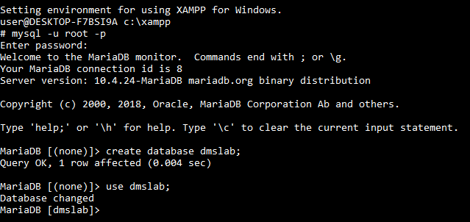

Based on purpose the main entities and their attributes are identified

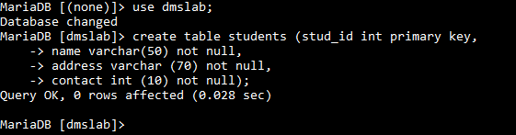

Data was added to each table using INSERT INTO statements



To describe the structure of table “Desc” statement was used

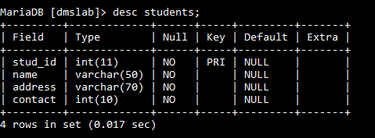

To display content from table “select” statement was used

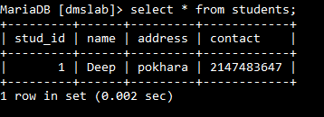

To delete database “DROP DATABASE database_name; ” command is used

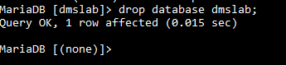

**Conclusion**

In this lab the objective was to design a simple database. We successfully designed a simple database using basic operations.

**LAB 2**

**Objective: To query and manipulate data in database**

**THEORY**

Manipulating and querying data are essential aspects of working with relational databases. Data Manipulation Language (DML) in SQL includes commands to insert, update, delete, and retrieve data from tables, enabling users to manage and analyze data effectively.

**Demonstration**

Basic query

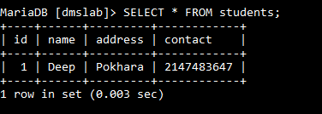

Conditional query

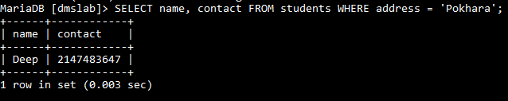

To modify existing records

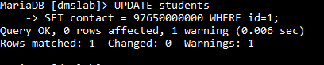

To delete table

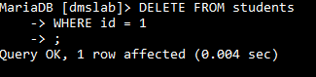

**Conclusion**

In this lab the objective was to query and manipulate data in database. Querying and manipulating data are fundamental operations in database management, enabling efficient handling of large datasets. Mastery of these techniques is essential for effectively managing relational databases and driving data-driven decisions.

**LAB 3**

**Objective: To Retrieve Data From Different Tables Using Joins**

**Theory**

Data retrieval in MySQL is primarily done using the SELECT statement.Data retrieval from different tables using joins in MySQL allows you to combine rows from two or more tables based on a related column between them.

**Demonstration**

To demonstrate joins tables are created

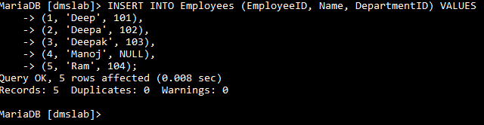

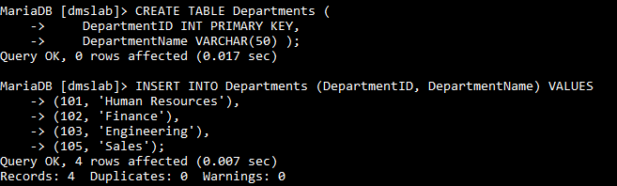

Here are the main types of joins:

**1. Inner Join**

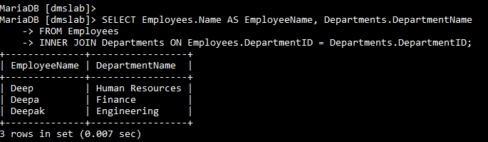

**2. Left Join**

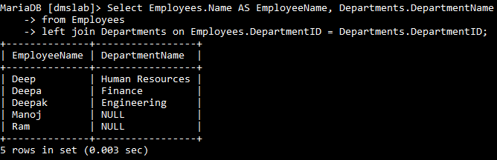

**3. Right Join**

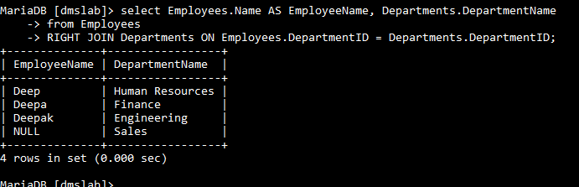

**4. Cross Join**

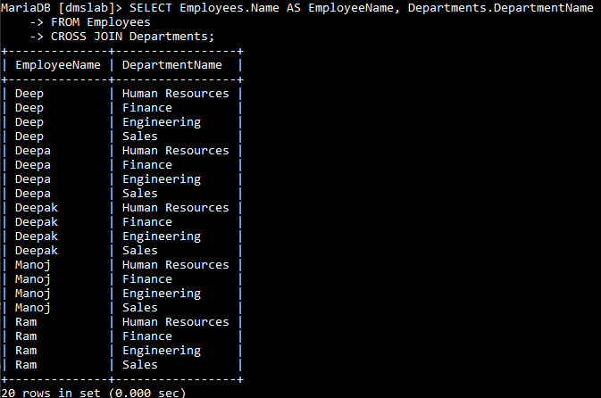

**Conclusion**

Using SQL joins, we can effectively retrieve and combine related data from multiple tables. Each type of join serves specific use cases, enhancing the flexibility and power of relational databases for complex queries.